Javascript Engine is different and Runtime environment is different… javascript engine kadhi ekta nahi milnar… te nehmi eka runtime environment madhe milanar jasaki browser, node environment

General Knowledge of JS

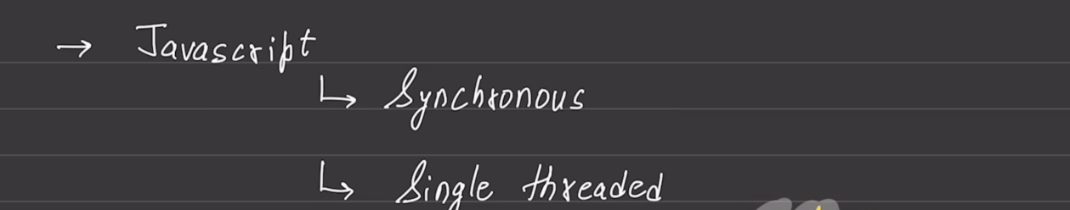

Synchronous means adi ek code execute honar mg dusra code execute honar and so on

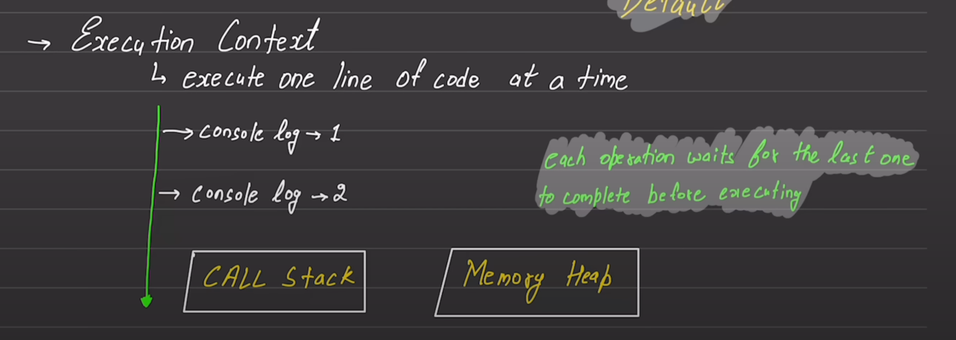

Working of Async

DOM chi API fkt browser madhe sapadli jate

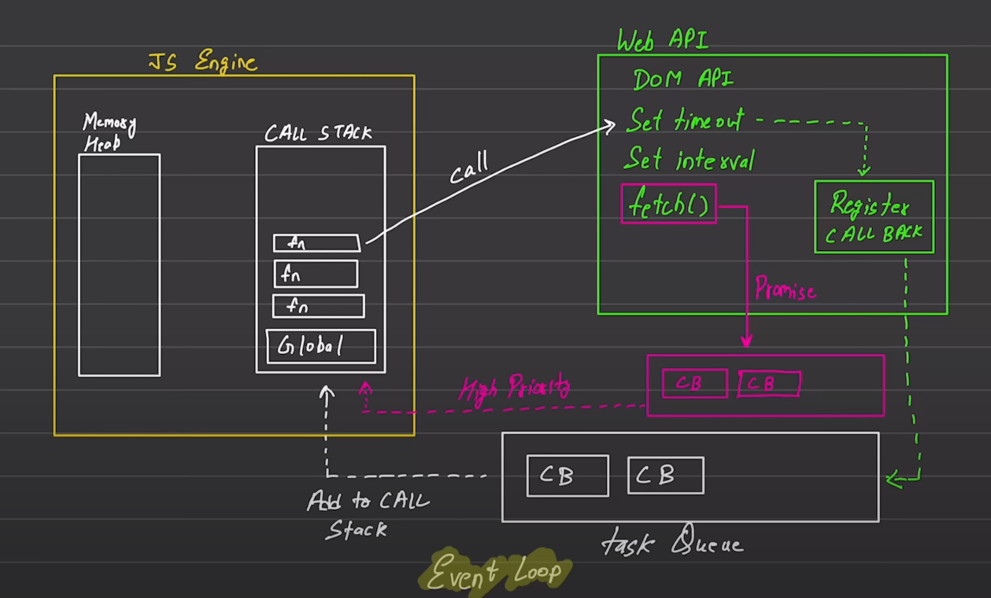

API bharpur prakar chya astat .. hya async chya context madhe web API / node API sangitlya aahet

setTimeout() madhe tya particular interval nantr ha (ek prakar che set of instructions execute vhyla pahijet ) -> callback execute vhyla pahijet

te callback eka register callback madhe register hotat and then task Queue madhe add kele jatat ani time ala ki parat call stack madhe load kele jatat for further execution.

Fetch() is a special type of function which returns a promise object and is enqueued in a special type of a high priority queue … tyancha execution la priority dili jate

Register callbacks madhe saglya events la register karun thevnar ani one by one task Queue madhe add honar

Basic expectation of the below notes:

Basic understanding about XMLHttpRequest Object and its ready state …

Practically implemented XMLHttpRequest Object in the code to get the information of my GitHub repository

the **XMLHttpRequest** (XHR) object was a traditional way to perform asynchronous requests in JavaScript. It was widely used for making HTTP requests to a server and fetching data without requiring a page reload. **XMLHttpRequest** was introduced in the late 1990s and became a fundamental part of many web applications.

One Simple Project/task : Task is to make an API call and print one of the desired or relevant information to the console

XMLHttpRequest Object is a traditional way for communicating with the server

The **XMLHttpRequest** object in JavaScript is used to make HTTP requests to a server and retrieve data. The **readyState** property of the **XMLHttpRequest** object indicates the state of the request at any given time.

The **readyState** property can have different values:

1. **0 (UNSENT):** The **XMLHttpRequest** object has been created, but the **open** method has not been called yet.
2. **1 (OPENED):** The **open** method has been called, indicating that the request is ready to be configured. You can set the HTTP method (GET, POST, etc.) and the URL at this stage.
3. **2 (HEADERS_RECEIVED):** The **send** method has been called, and the request headers and status are now available. This state signifies that the server has been contacted, and its response headers are received.
4. **3 (LOADING):** The request is in progress. This state indicates that the response is being received. You can check the **responseText** property to see the current response.
5. **4 (DONE):** The request is complete, and the entire response, including the data, is received. You can check the **status** property to see the HTTP status code, and the **responseText** or **responseXML** property to get the actual data.

Here's a simple breakdown:

* **0:** Just created, not configured.
* **1:** Configured, but not sent.
* **2:** Headers received, but the response body hasn't fully arrived.
* **3:** Downloading; receiving data.
* **4:** Done; the entire response is available.

Developers use the **readyState** property in conjunction with event listeners to track the progress of the request and take appropriate actions based on its current state. For example, they might update a loading indicator while the request is in progress or process the received data when the request is complete.

Promises chi sagli theory me code file madhe lihili ahe

Something about fetch:

Fetch sathichi queue vegli aste and which is a high priority queue

Ek important information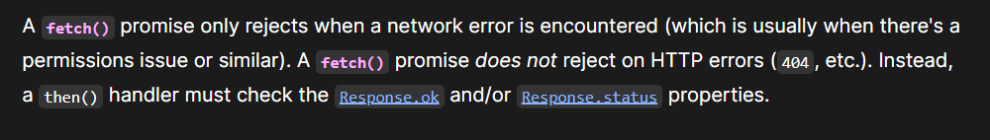

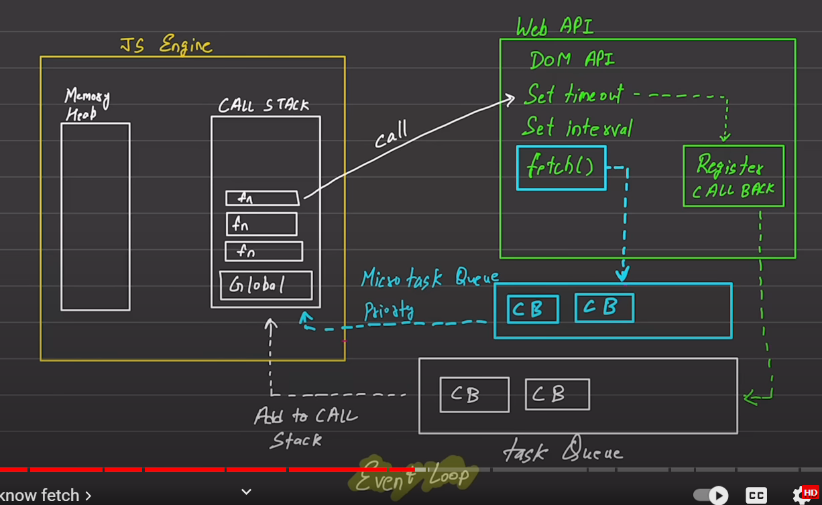

How fetch actually works?

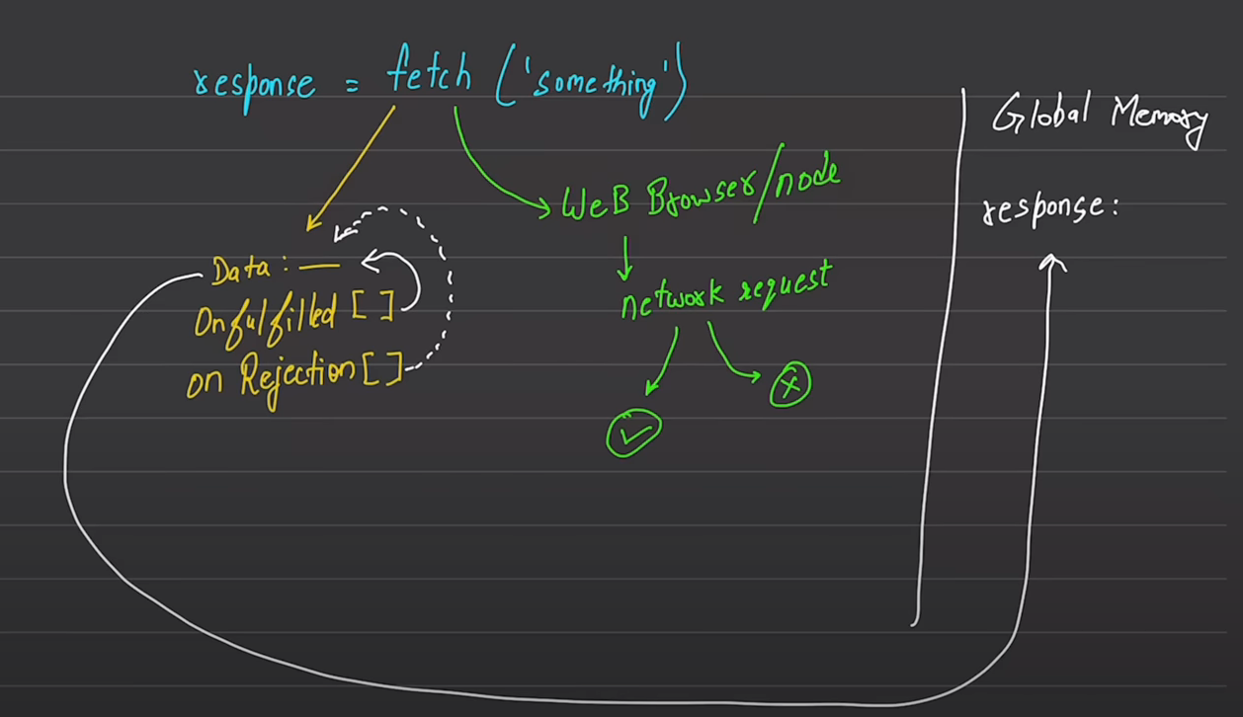

Jyaveli pn me fetch lihinar tasa 2 goshti honar/ 2 kam honar

1 kam means web request kiva node request handle karne :network request prepare karne and then network madhe javoon kam karne

Dusra kam means jo pn data yeil tyasathi appropriate memories / variables reserve karne … tr according to the diagram

3 variables are declared :

One holds data (this data is not accessible for naïve developer or user)

One is onfulfilled array[] and another is onrejected array[]…

404 ch error’s file not found che errors onFulfilled array madhech janar